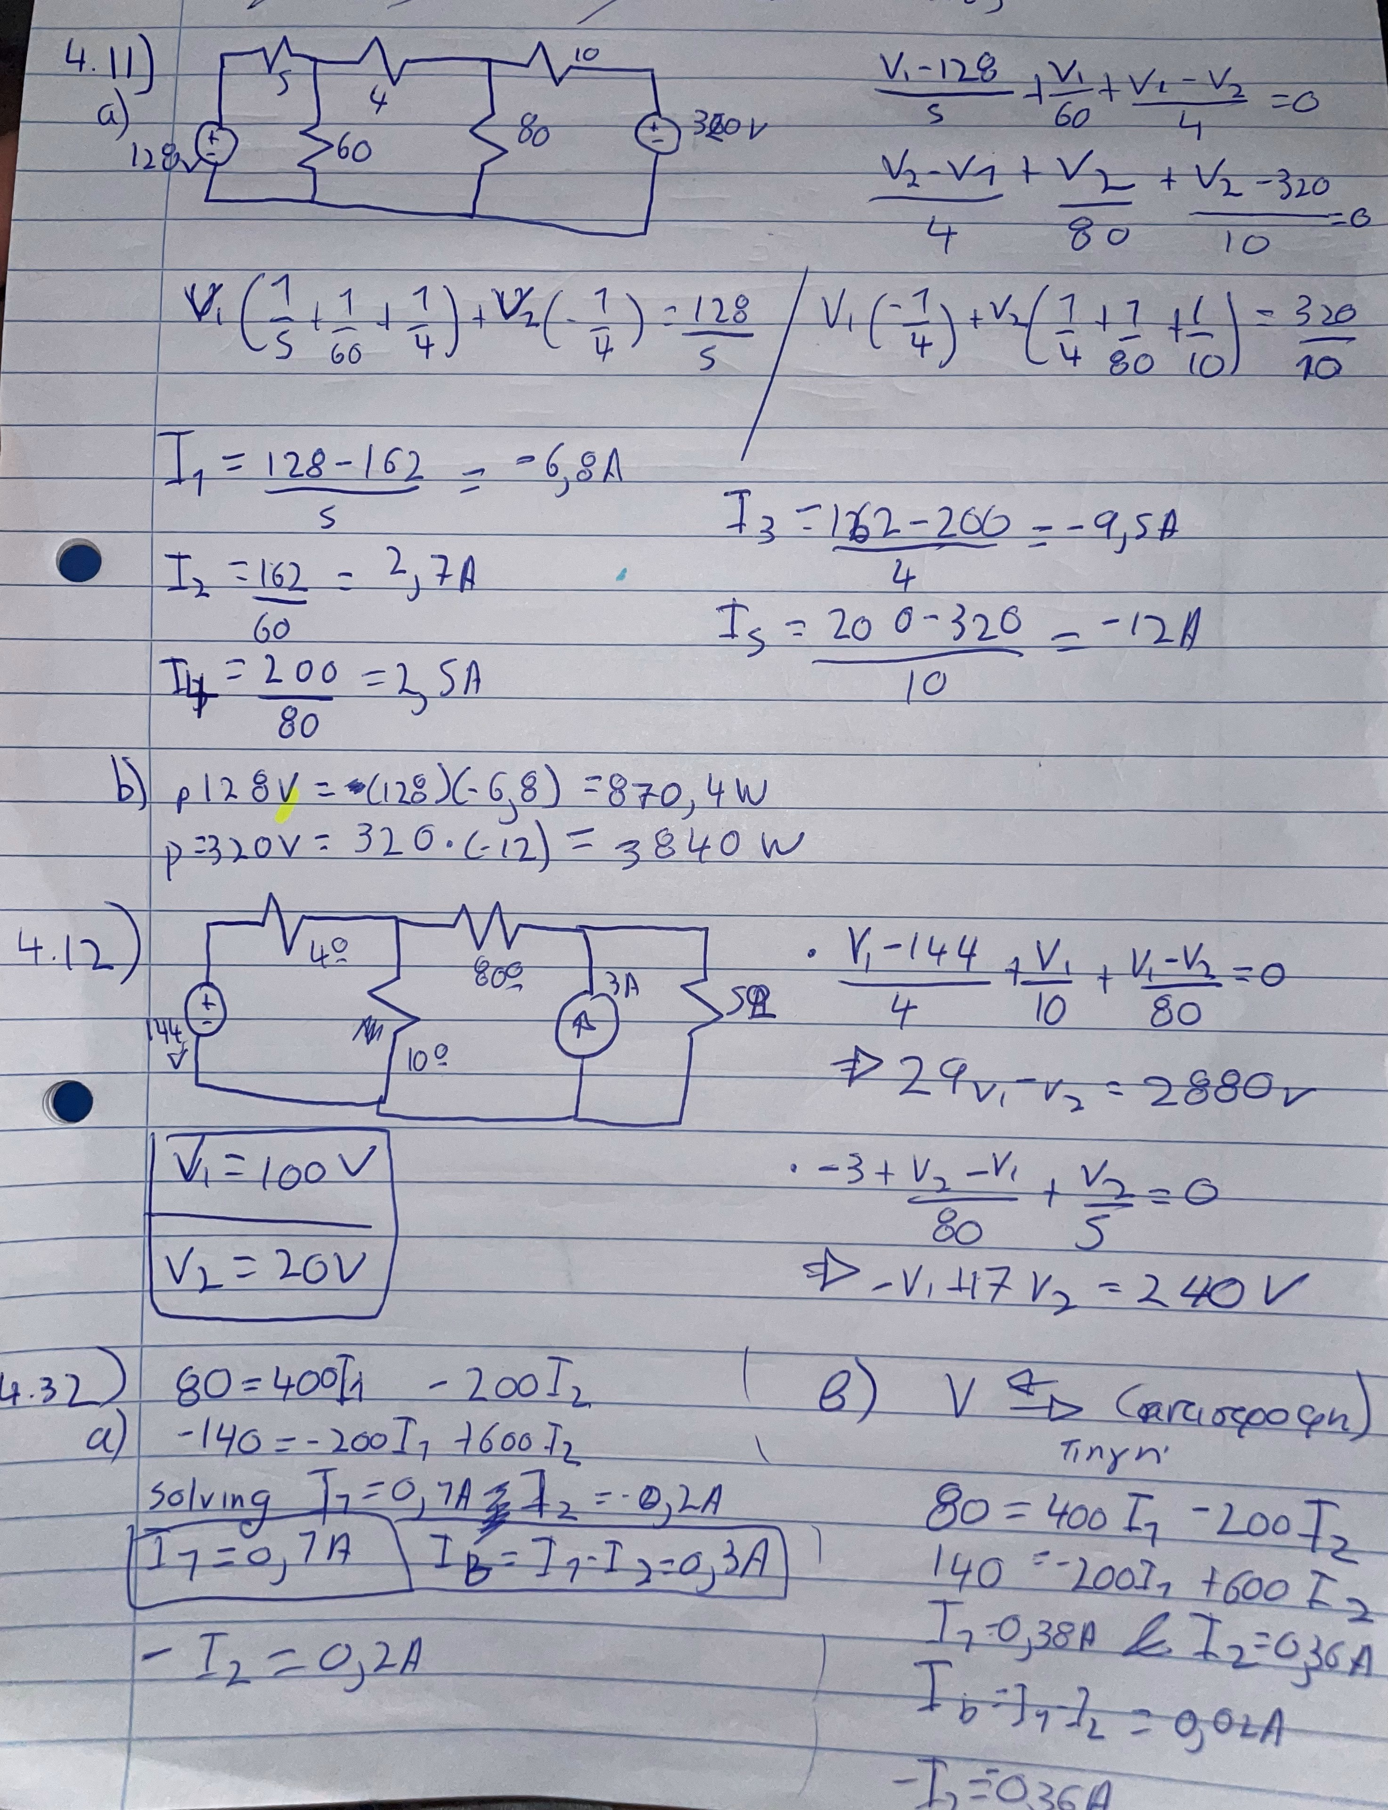
Ασκησεις ΗW3: Karyos Giorgos - (30738)
.

